Newcastle 2022
Tuesday 11 – Friday 14 October

Name:
Class:

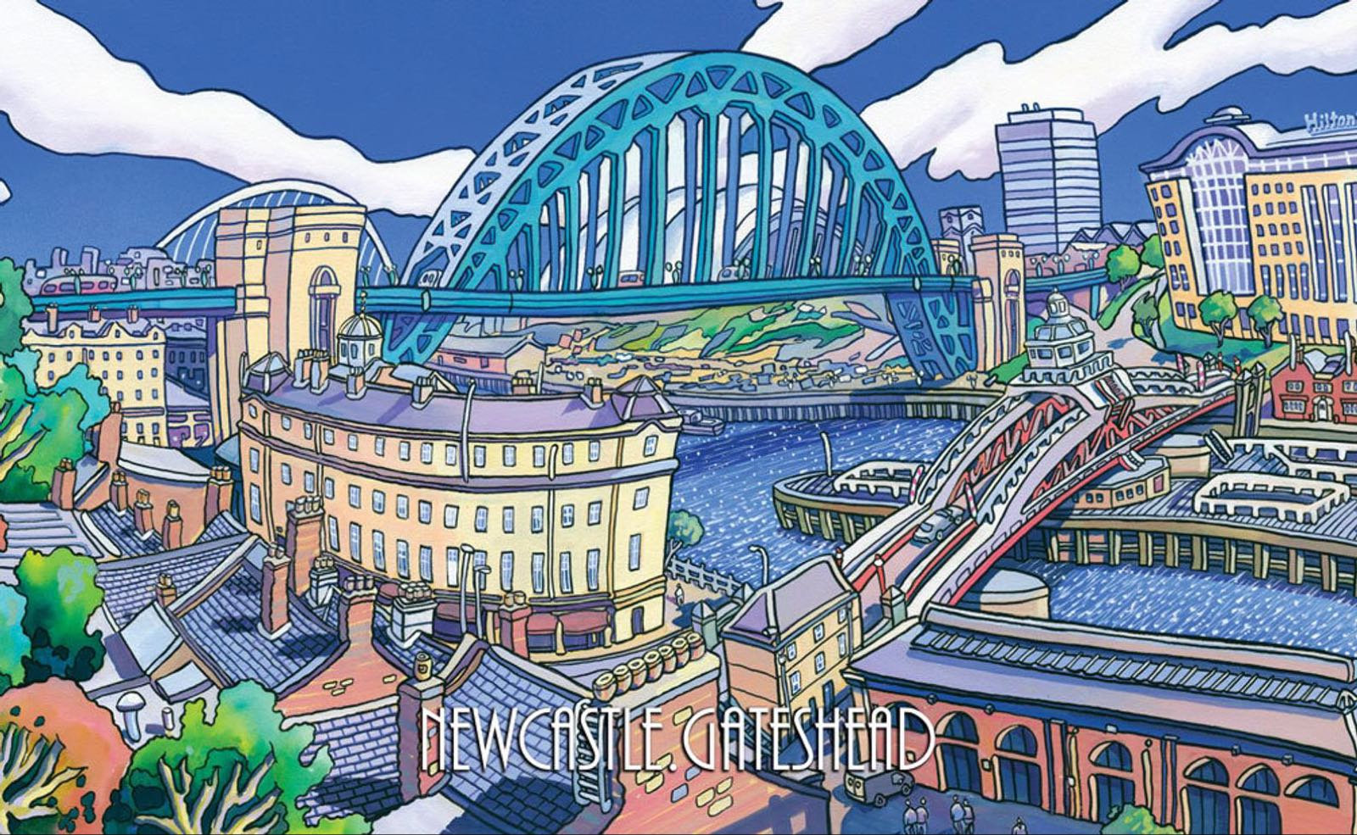

Dear students,

We hope you’ll have an amazing time during our Newcastle trip and we expect you to cooperate to make it a great success!

Read this booklet very carefully, so you know what you’re going to do and what you need.

Before departure we meet at the DFDS ferry in IJmuiden. Your parents will have to drop you off on Tuesday and pick you up on Friday. It might be a good idea for some parents to arrange a carpool.
The address:
Felison Terminal
Sluisplein 33
1975 AG in IJmuiden

You can bring your phone on the trip, but your tutor will tell you when you can use it and when you cannot. On the ferry phone costs are very high as they charge maritime tariffs, so have you phone on flight mode/off the entire journey! When you arrive in the United Kingdom the costs will be the same as in European countries.

First of all, some home rules of the hostel:
- Only use the emergency exit IN CASE OF EMERGENCY
- Keep your room clean. It will be checked daily!
- During the night, you’re only allowed to stay in YOUR OWN ROOM
- After 23:00 you may still talk with your roomies, but keep the volume down. After 00:00 it has to be completely quiet!
- You will speak English all the time: with both students and teachers.

You’re not allowed to bring:
- Aerosols (cans with gas)
- Video games
- Big bags of sweets/crisps

On behalf of all the teachers and supervisors, we wish you a great trip!

Contact details:
YHA Hostel Newcastle Central  17 Carliol Square  Newcastle Upon Tyne  Northumberland, NE1 6UQ  Phone: +44 345 260 2583 | St Mary’s Catholic School  Benton Park Road  Newcastle Upon Tyne  NE7 7PE  Phone: +44 191 215 3260

Things to pack:
- 4 sets of clothes
- Neat clothes for school visit
- Warm and waterproof clothes
- Rainwear
- Small games
- Pocket money (not necessary, but it is allowed)
- Phone
- Journal (first year students)
- Pens
- Notebook

You can add other stuff to your own packing list:
- …
- …
- …
- …
- …
- …
- …
- …
- …
- …

This will be an immersion camp you will never forget! It’s going to be AMAZING!

Tuesday 11 October – NL time
15.00 Gather at the ferry
17.00 Dinner on the ferry
17.30 Departure ferry
20.00 Evening activity
22.00 Everyone to their rooms: you’re not allowed to be in the hallways.
23:00 Bed time

Wednesday 12 October
07.15 Wakeup call + clean rooms
08.00 Breakfast + packed lunch
09.15 Arrival in Newcastle
10.15 Drop off luggage at hostel
1st year | 2nd year
11.00 Depart for school | 11.00 – 12.00 Tour through Newcastle
12.30 – 15.30 Visit St Mary’s Catholic School including lunch | 12.00 – 15.00 Visit the discovery museum including lunch

16.30 – 19.00 Bowling, games and dinner
20.00 – 21.30 Evening activity
22.00 Everyone to their rooms: you’re not allowed to be in the hallways.
23:00 Bed time

Thursday 13 October
07.00 Wake-up call!
07.15 Breakfast
1st years | 2nd years
09.00 – 11.00 Tour through Newcastle + souvenir shopping | 07.45 Depart for school
11.00 – 14.00 Visit the discovery museum | 8.30 – 11.30 Visit St Mary’s Catholic School including lunch
 | 12.30 – 14.00 Souvenir shopping

14.00 – 14.30 Back to hostel to pick up bags
14.30 To ferry by bus
17.00 Departure
17.45 Dinner on the ferry
20.00 Free time on the ferry – there are multiple things to do on the boat, but you’ll have to pay for them yourselves, or you could play your self-brought games with your classmates.
22.00 Everyone to their rooms: you’re not allowed to be in the hallways.
23:00 Bed time

Friday 14 October
8.00 Wake-up call + clean your rooms
8.45 Breakfast
9.45 Arrival IJmuiden

